EF Classes and Unit Tests
My repository is accessible at https://github.com/CharlieKnittel/mis442.

Ingredient Unit Tests
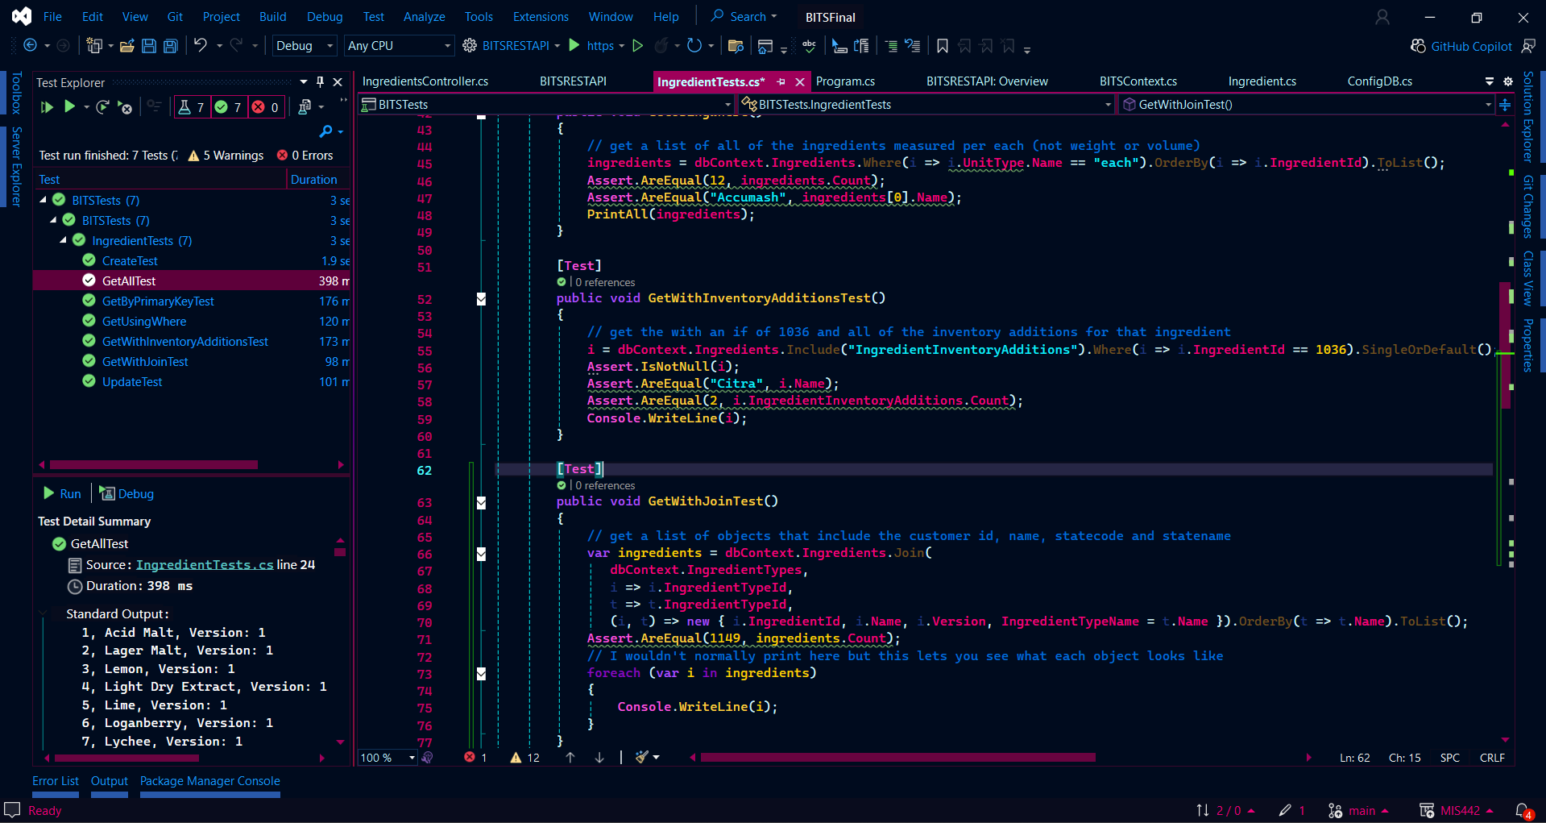
Other relevant classes to test include IngredientType, UnitType, IngredientInventoryAddition, and IngredientInventoryAddition.

I did not create a unit test for ingredient deletion because this would involve modifying the database creation sql to enable a SQL deletion cascade, and this is not relevant to the scope of my use case.
If implemented, a deletion unit test would look like:
[Test]
public void DeleteTest()
{
i = dbContext.Ingredients.Find(3);
dbContext.Ingredients.Remove(i);
dbContext.SaveChanges();
Assert.IsNull(dbContext.Ingredients.Find(3));
}
